# Báo cáo bài tập

Cài đặt 2 plugin vào elipse:

Eclipse CFG generator : [**http://eclipsefcg.sourceforge.net/**](http://eclipsefcg.sourceforge.net/)

CodeCover: **http://update.codecover.org/**

1. **package** example1;
2. **import** java.util.Scanner;
3. **public** **class** main {
4. **public** **static** **void** main(String[] args) {
5. // **TODO** Auto-generated method stub
6. **int** a ,b;
7. Scanner sc = **new** Scanner(System.*in*);
8. **while**(**true**){
10. System.*out*.println("Nhap a: ");
11. a= sc.nextInt();
12. System.*out*.println("Nhap b: ");
13. b= sc.nextInt();
15. **if**(b!=0){
16. System.*out*.println(a + "/"+b+" = "+a/b);
17. **break**;
18. }
19. **else**
20. {
21. System.*out*.println("b =0");
22. }
23. }//end while
24. }//end main
25. }//end class main

## Sử dụng eclipse CFG generator được sơ đồ sinh ra từ code trên:

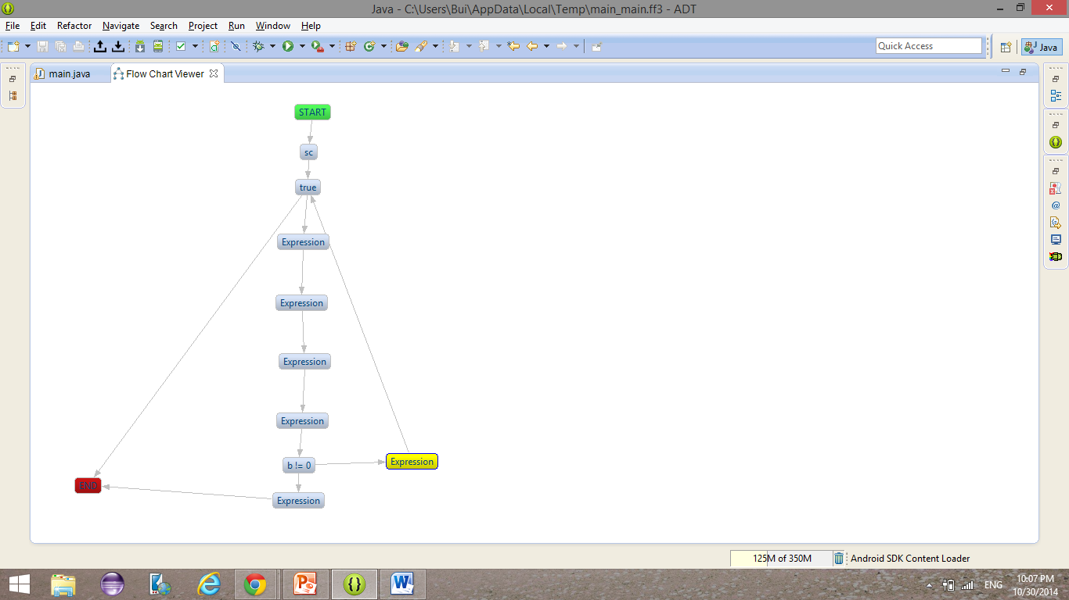

Tạo ca kiểm thử C1P:

**package** example1;

**import** java.util.Scanner;

**public** **class** main {

**public** **static** **void** main(String[] args) {

// **TODO** Auto-generated method stub

**int** a, b;

Scanner sc = **new** Scanner(System.*in*);

System.*out*.println("Nhap a:");

a = sc.nextInt();

**if**(a != 0){

System.*out*.println("Nhap b:");

b = sc.nextInt();

System.*out*.println("b/a" + b/a);

}

**else**

{

System.*out*.println("End.");

}

**int** c, d;

System.*out*.println("Nhap c:");

c = sc.nextInt();

**if**(c != 0)

{

System.*out*.println("Nhap d:");

d = sc.nextInt();

System.*out*.println("d/c =" + d/c);

}

**else**

System.*out*.println("End.");

}//end main

}//end class main

Test Case :

1. a=1,b=2,c=0;

2. a=1,b=2,c=1,d=2;

3. a=0,c=0;

4. a=0,c=1,d=2;